UNIVERSITY OF SKILLS TRAINING AND ENTREPRENEURIAL DEVELOPMENT
FACULTY OF APPLIED SCIENCES AND MATHEMATICS EDUCATION
DEPARTMENT OF INFORMATION TECHNOLOGY EDUCATION

DESIGN AND DEVELOPMENT OF A SMART INFORMATION DISSEMINATION SYSTEM FOR ENHANCED STUDENT COMMUNICATION IN HIGHER EDUCATION

BADU ADWOA NTIRIWAA - 5221040008
APPIAH JUSTICE BARFO - 5221040041
ASARE EDMUND BEDIAKO - 5221040297
THEOPHILUS KING ASARE - 5221040017
KYEI GYAMFI SOLOMON – 5221040042

JULY, 2026

CHAPTER FOUR
SYSTEM DEMONSTRATION AND EVALUATION

4.1 Chapter Introduction
This chapter provides the structure for demonstrating and evaluating the Smart Information Dissemination System. It describes the experimental setup, the system demonstration procedure, screenshot evidence, testing levels, functional test cases, non-functional evaluation, and user-acceptance activities. Final screenshots, measured values, and pass or fail decisions must be inserted after the implemented prototype has been tested.
The evaluation criteria correspond directly to the project objectives and proposal targets. They include functional accuracy, response time, notification reliability, usability, task completion, user satisfaction, security, access control, reliability, information quality, and accessibility.

4.2 System Demonstration

4.2.1 Experimental/Simulation Setup
Component | Test Configuration
Application and database server | Modern multi-core processor, at least 8 GB RAM, PostgreSQL database, secure storage, and backup support.
Administrator and lecturer computer | Laptop or desktop with at least 4 GB RAM and a current browser.
Student and applicant device | Smartphone, tablet, laptop, or desktop with a current browser.
Network | Internet or institutional network access with HTTPS in the production environment.
External services | SMTP test account, SMS sandbox or test credentials, cloud file storage, and optional SIS test endpoint.
Table 4.1: Hardware and service setup
Software Area | Test Environment
Frontend and application | Next.js, React, TypeScript, Tailwind CSS, and reusable components.
Server and API | Next.js server routes or compatible Node.js service layer.
Database and ORM | PostgreSQL and Prisma ORM.
Browsers | Current Chrome, Edge, Firefox, and mobile browser.
Testing tools | Automated unit tests, Postman, browser developer tools, accessibility checker, and load-testing utility.
Delivery services | In-app notification service, SMTP email test service, and SMS sandbox.
Table 4.2: Software test environment

4.2.2 Demonstration Procedure
- Create the institution, faculties, departments, programmes, courses, class groups, academic year, and semester.
- Create users and assign the super administrator, institution administrator, department administrator, lecturer, student, and applicant roles.
- Sign in as an institution administrator and create an announcement with title, body, category, priority, publication time, and optional attachment.
- Select an audience based on role or academic structure and verify the resolved recipient list.
- Publish the announcement and confirm the creation of in-app notifications and configured email or SMS delivery tasks.
- Sign in as a targeted student and verify that the notice appears in the dashboard, unread list, notification centre, search results, and archive.
- Open the announcement and confirm that the read record and unread count are updated.
- Sign in as a non-targeted user and confirm that the restricted announcement is not accessible.
- Create a lecturer-to-course message thread and verify participant restrictions and read state.
- Create or update an academic schedule and confirm that the affected audience receives the appropriate notice.
- Change a notification preference and verify that permitted channels follow the preference while mandatory notices remain available in the application.
- Review delivery records, read reports, failed delivery information, communication analytics, and administrative audit logs.

4.2.3 Screenshots of Key Operations
Figure 4.1: Login and role-specific dashboard
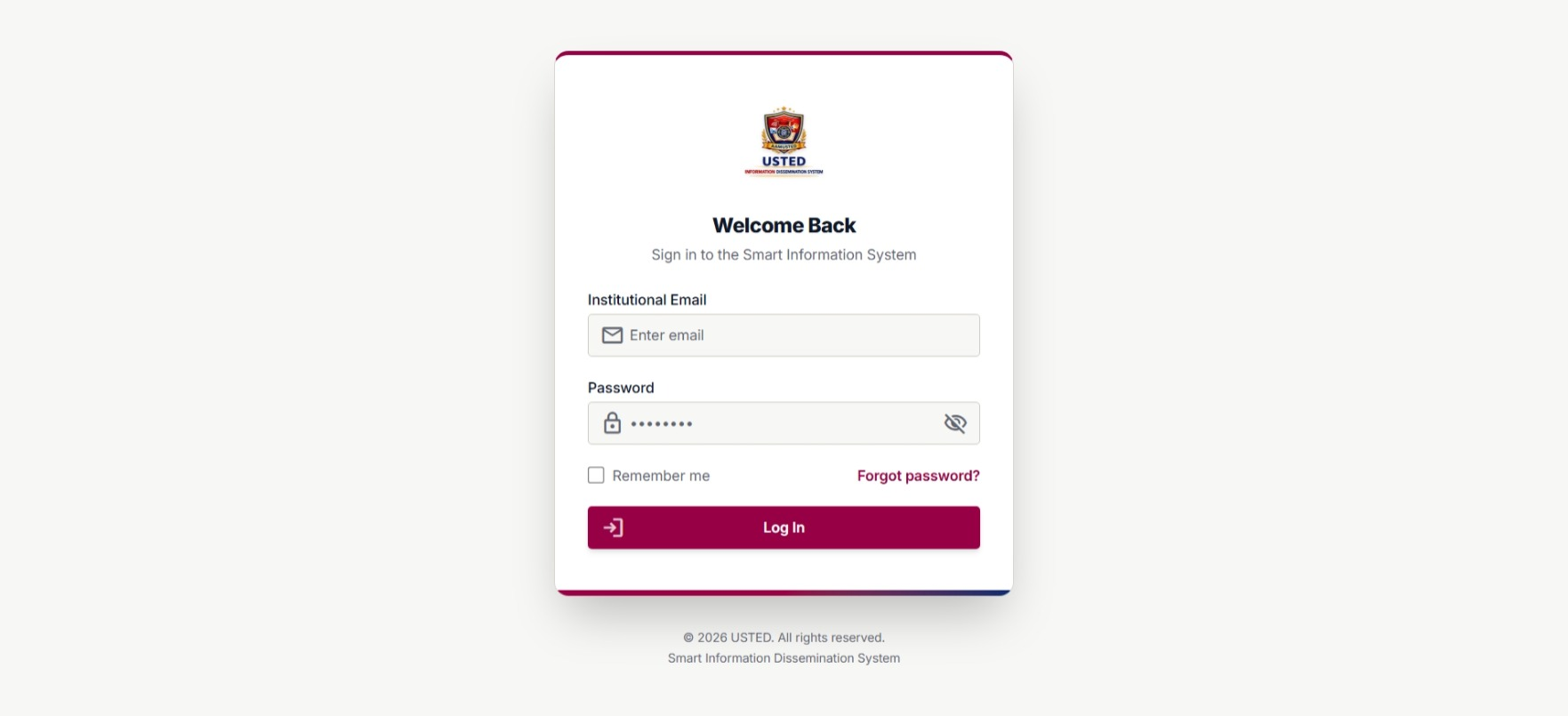
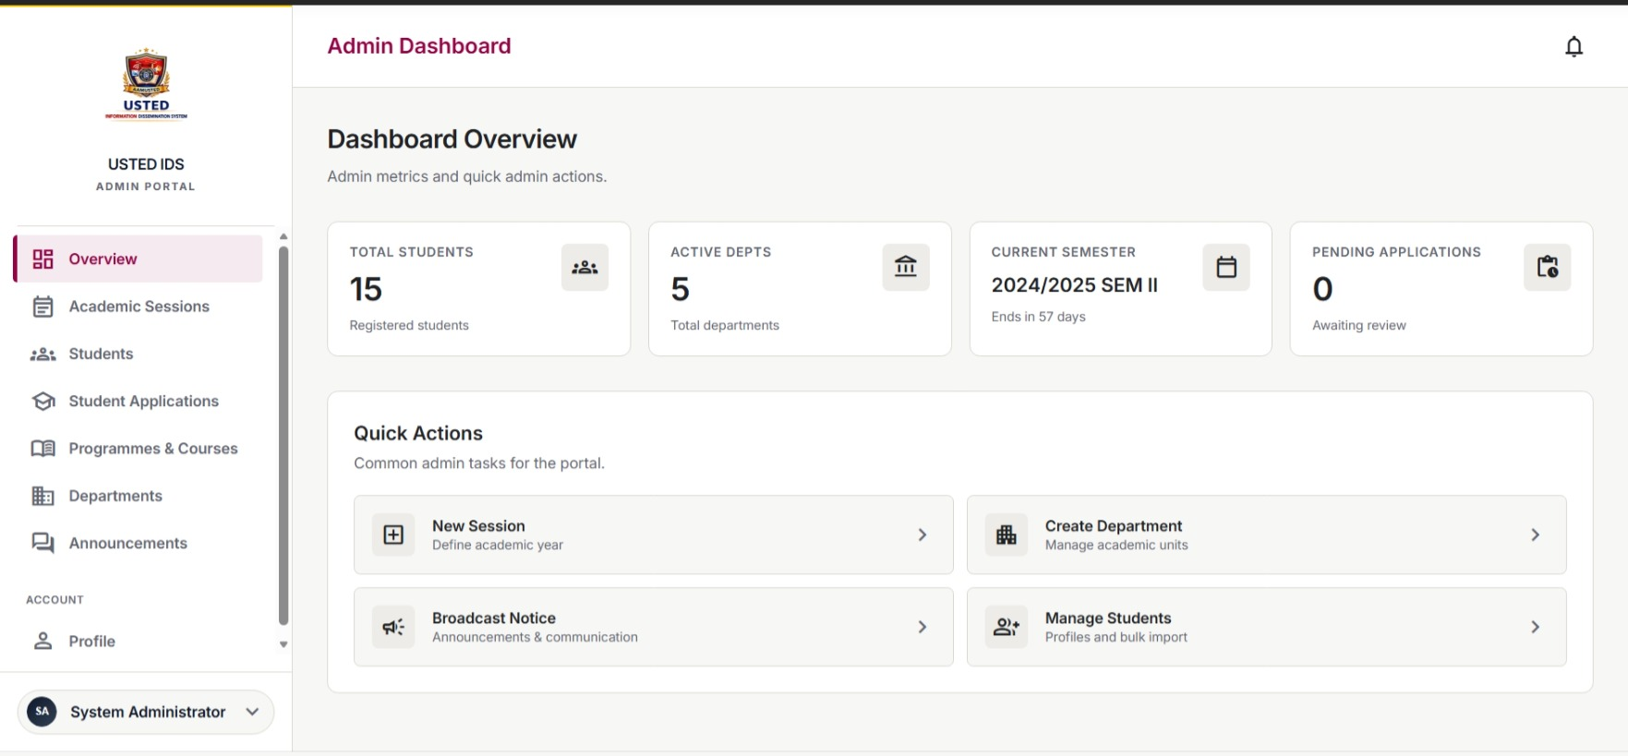
Figure 4.1: Login and role-specific dashboard
Figure 4.2: Institutional and academic structure management
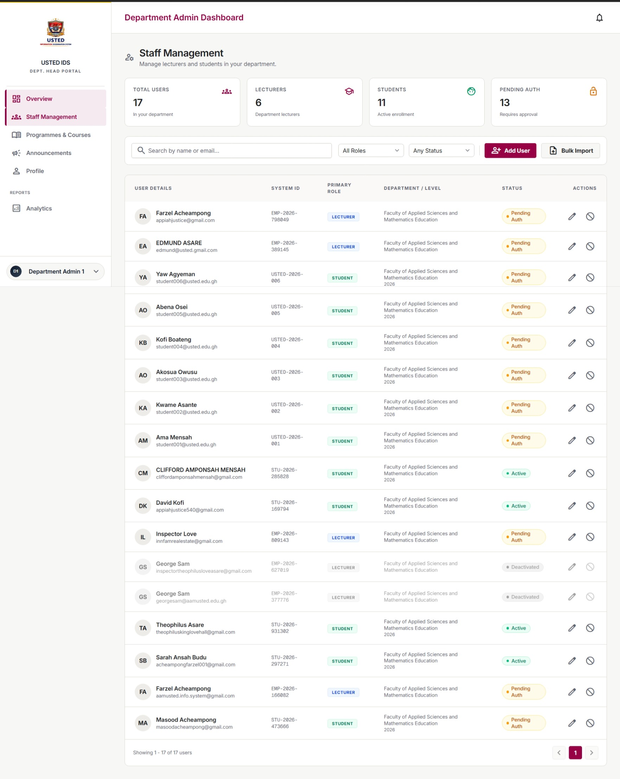
Figure 4.2: Institutional and academic structure management

Figure 4.3: Announcement creation
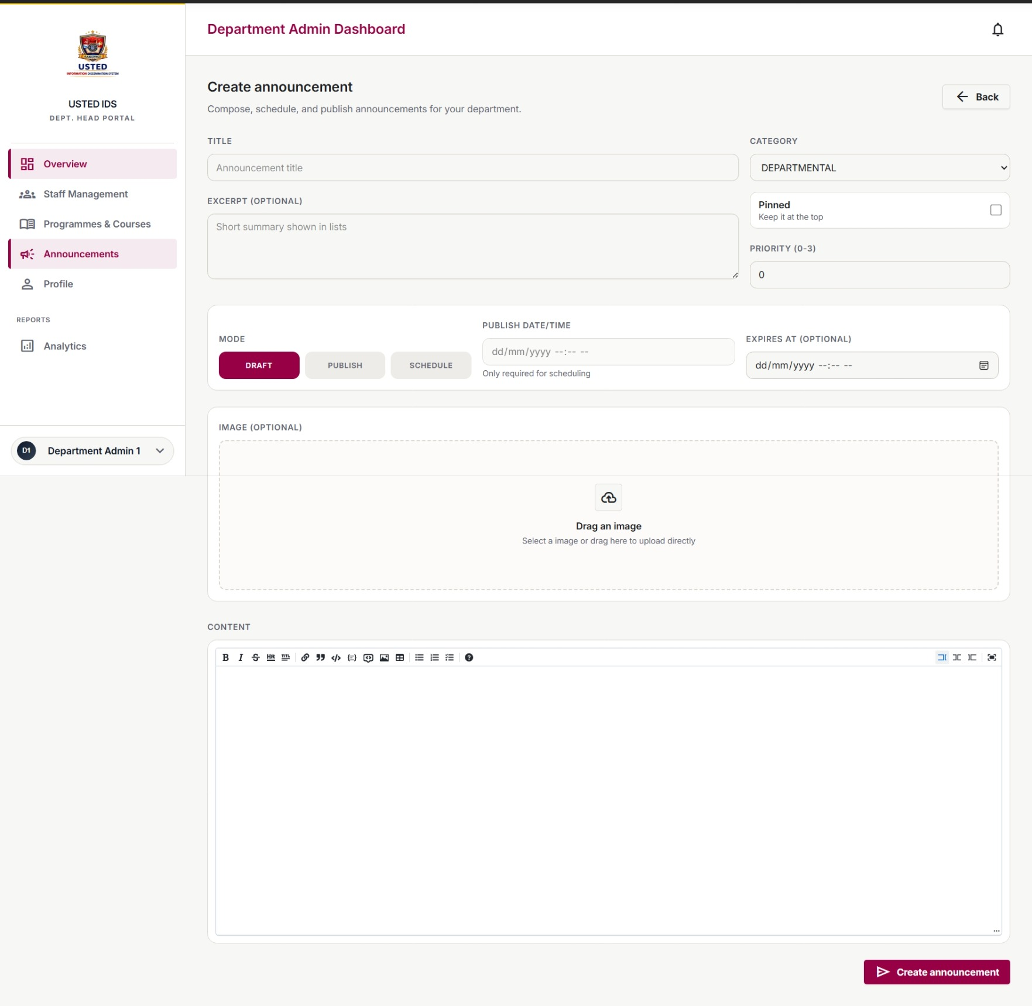
Figure 4.3: Announcement creation

Figure 4.4: Audience selection and recipient preview
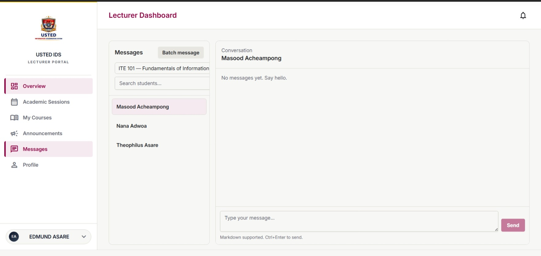
Figure 4.4: Audience selection and recipient preview
Figure 4.5: Student notice and notification centre
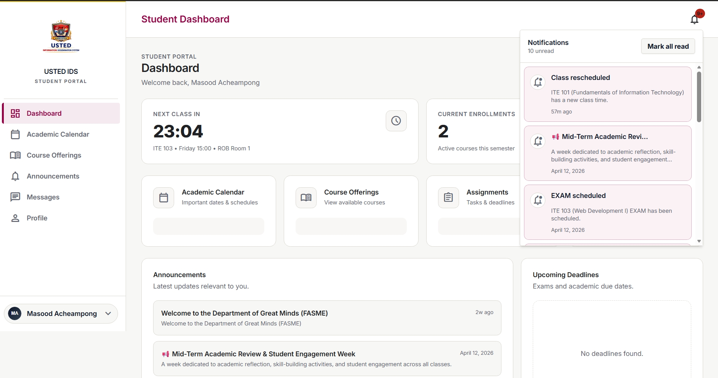
Figure 4.5: Student notice and notification centre

Figure 4.6: Email or SMS delivery status
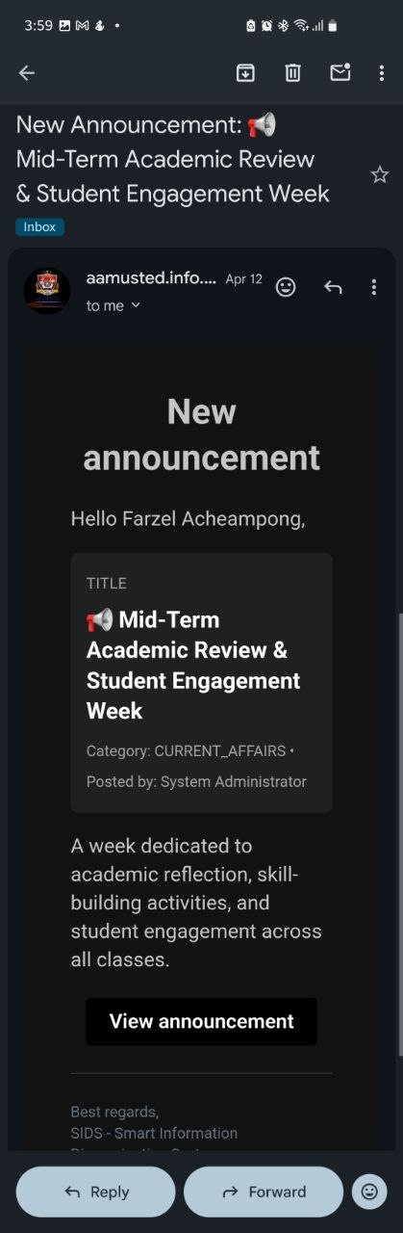
Figure 4.6: Email or SMS delivery status
Figure 4.7: Messaging thread
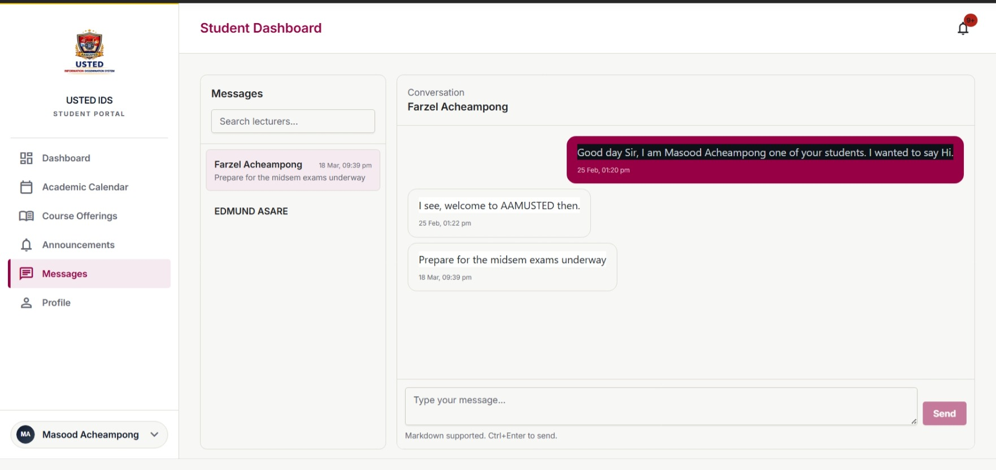
Figure 4.7: Messaging thread
Figure 4.8: Academic schedule
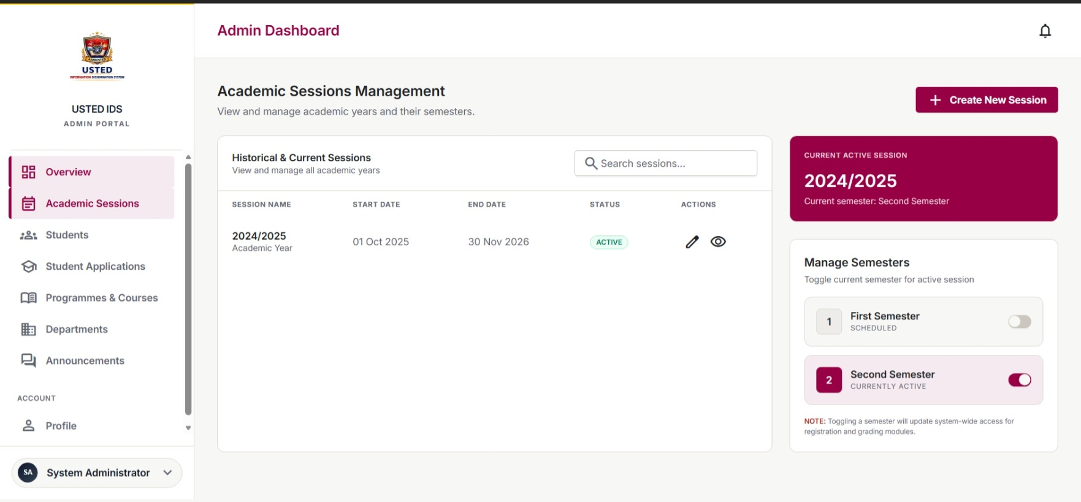
Figure 4.8: Academic schedule

Figure 4.9: Reporting and audit log
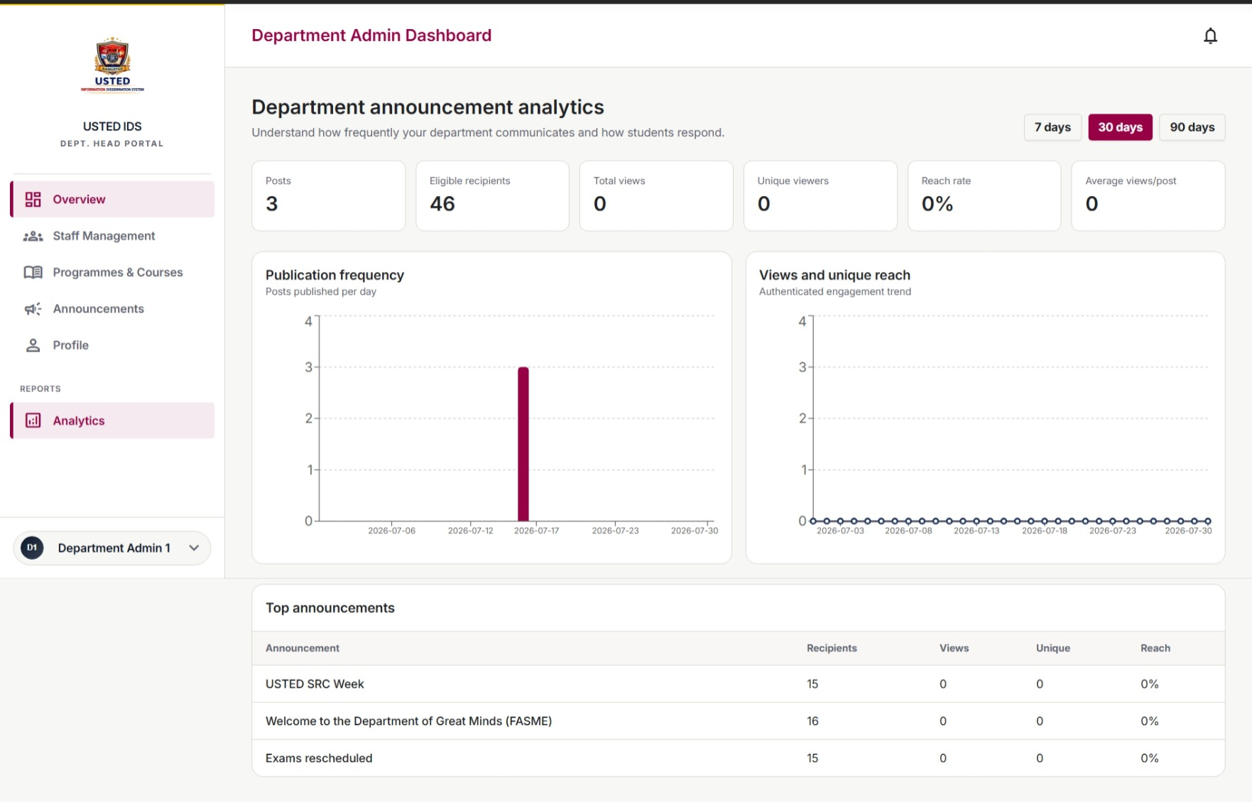
Figure 4.9: Reporting and audit log

4.3 System Evaluation
Evaluation will combine unit, API, integration, system, security, performance, accessibility, and user-acceptance testing. Black-box testing will determine whether inputs produce the expected outputs, while unit tests will verify internal business rules. Test records will include valid, invalid, unauthorized, duplicate, delayed, and provider-failure scenarios.

4.3.1 Functional Evaluation
Test ID | Function | Test Data/Action | Expected Result | Status
FT-01 | Valid login | Correct credentials for an active user. | Open the correct role-specific dashboard. | Pending
FT-02 | Invalid login | Wrong password or inactive account. | Reject access and display a safe error. | Pending
FT-03 | Role authorization | Attempt a restricted page or API operation. | Deny access and record an appropriate event. | Pending
FT-04 | Create announcement | Valid title, body, category, audience, and schedule. | Save or publish the announcement according to status. | Pending
FT-05 | Invalid announcement | Missing content or invalid publication time. | Prevent publication and display validation messages. | Pending
FT-06 | Audience resolution | Select a department, programme, course, class group, or role. | Return only eligible recipients. | Pending
FT-07 | In-app notification | Publish a notice to a valid audience. | Create one notification per eligible recipient without duplicates. | Pending
FT-08 | External delivery | Send email or SMS through a test provider. | Record success or failure and provider response. | Pending
FT-09 | Read tracking | Targeted user opens an unread notice. | Create or update the read record and unread count. | Pending
FT-10 | Unauthorized notice access | Non-recipient requests a restricted notice. | Deny access. | Pending
FT-11 | Messaging thread | Authorized user starts or replies to a thread. | Store the message and update participant states. | Pending
FT-12 | Schedule update | Authorized user creates or changes an academic schedule. | Save the schedule and notify the affected audience. | Pending
FT-13 | Preference update | User enables or disables a permitted channel. | Apply the preference to future optional delivery. | Pending
FT-14 | Search and archive | Search by keyword, date, category, author, or audience. | Return matching authorized content. | Pending
FT-15 | Report and audit | Generate a communication report after test activity. | Report totals match records and sensitive actions appear in the audit log. | Pending
Table 4.3: Functional evaluation test cases

4.3.2 Non-Functional Evaluation
Metric/Attribute | Measurement Method | Target | Status
Functional accuracy | Passed functional tests divided by total executed tests x 100. | At least 90%. | Pending
Response time | Measure login, dashboard, search, notice loading, and publication requests. | Most common actions within 3 seconds under the agreed test load. | Pending
In-app notification reliability | Successful in-app notifications divided by attempted notifications x 100. | At least 95%. | Pending
Task completion | Users complete assigned tasks without critical assistance. | At least 85%. | Pending
User satisfaction | Five-point questionnaire on usefulness and ease of use. | Mean score of at least 4.0. | Pending
Access control | Attempt restricted pages and API operations with different roles. | No critical access-control failure. | Pending
Reliability | Repeat publication, delivery, read, retry, and recovery tests. | No lost confirmed records or unintended duplicates. | Pending
Accessibility | Keyboard, focus, labels, contrast, error, and responsive-layout checks. | Critical issues corrected or documented. | Pending
Compatibility | Test supported desktop and mobile browsers. | Core workflows remain usable. | Pending
Backup and recovery | Restore database and files in a clean test environment. | Critical records restored accurately. | Pending
Table 4.4: Non-functional evaluation plan

4.3.3 User-Acceptance Testing
Participant Role | Representative Tasks
Super/Institution Administrator | Create structures and users; publish a targeted notice; inspect delivery, read reports, and audit logs.
Department Administrator | Publish a departmental notice and manage a department schedule within assigned scope.
Lecturer | Send a course notice or message to an assigned audience and review responses.
Student | Locate a targeted notice, open it, search the archive, view a schedule, and change a permitted preference.
Applicant | View an admission-related notice and schedule and confirm the associated notification.
IT/Support representative | Review failed delivery, logs, backup, and external-service configuration.
Table 4.5: User-acceptance tasks
For each task, the evaluator should record completion, time, errors, assistance, comments, and satisfaction rating. Results should be summarized by role and linked to the final functional and non-functional findings.

4.4 Chapter Summary
This chapter described the experimental setup, demonstration procedure, screenshot evidence, functional tests, non-functional measures, and user-acceptance activities for the Smart Information Dissemination System. The chapter does not present unverified results as completed evidence. After implementation, all placeholders and pending statuses should be replaced with actual screenshots, measurements, participant results, defects, corrections, and final decisions.

